More Damning Evidence for the Report ‘Scientific Expert Report on the COVID-19 Epidemic Response in Ireland’
September / October 2021

The following provides supporting evidence and supplementary evidence for the ‘Scientific Expert Report on the COVID-19 Epidemic Response in Ireland’ by Jay Bhattacharya, MD, PhD and Professor of Medicine in Stanford University, USA. Approximately 33% of this Report.
Dr. Dolores Cahill, Professor of Science and Immunology, UCD. Immunologist.
Dr. Anne McCloskey, medical doctor
Dr. Patrick Morrissey, medical doctor
Mr. Edward Shanahan, Barrister in Ireland and author of Section U of this paper with assistance from D.E. MSc (NUI Galway and University of Oxford)

Excess Mortality in Ireland and Britain after covid19 vaccines were introduced in January 2021. Murder / Manslaughter via Experimental vaccines.
- Do the Gardai (Irish police) and DPP think politicians and NPHET and the CMO are above the law and can break criminal laws and civil laws which result in people being seriously injured or disabled or killed ? and also result in massive financial losses to Irish businesses and organizations ? the deaths and injuries and disabilities and massive economic losses itemized in these and other evidence documents have arisen from the actions of certain persons who must be held accountable.
- Statistics provided by RIP.ie and the General Registration Office (state body for registering all deaths) in Ireland shows a large increase excess mortality after the introduction of covid19 vaccines in 2021. There was a spike in excess deaths in January and February 2021. The increase has continued through the Summer months when excess mortality usually decreases. The rise in excess mortality has continued into Autumn 2021.
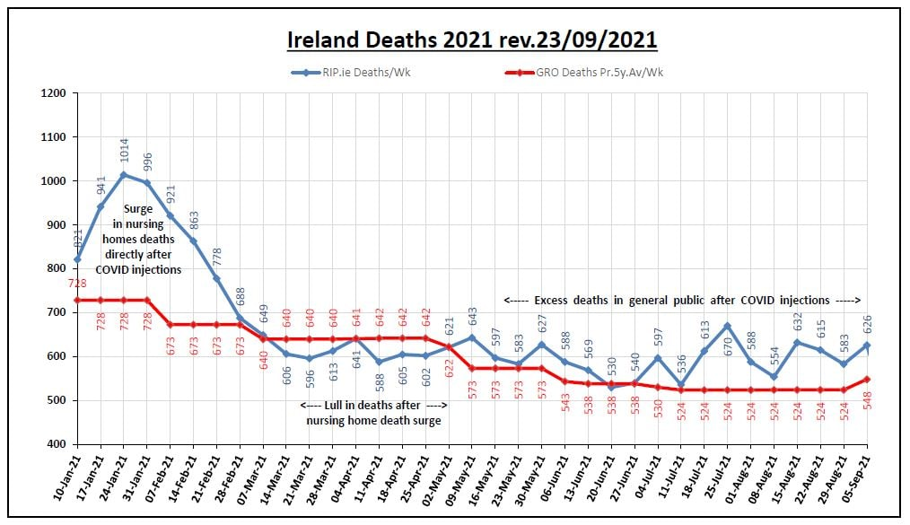
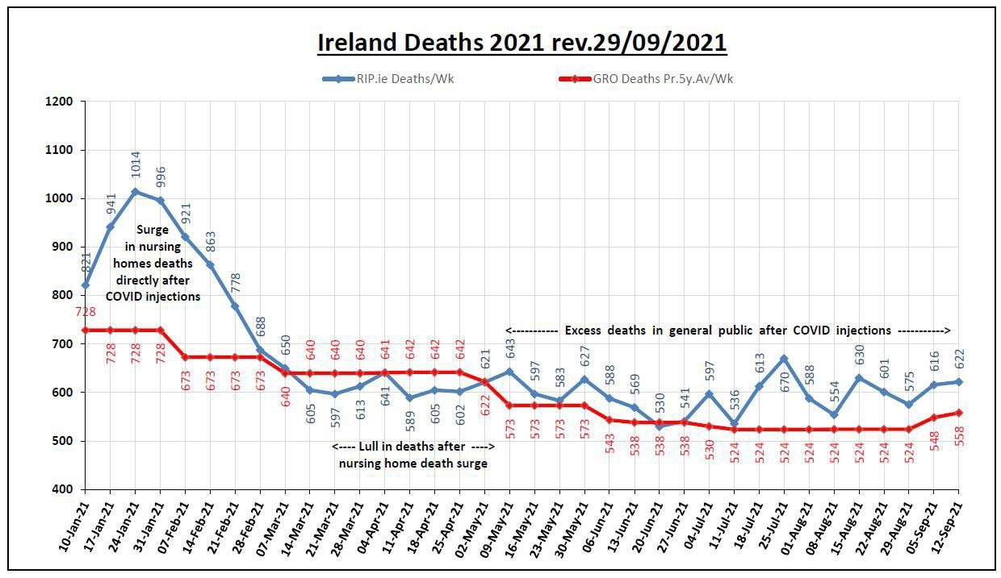
2,000 Excess Deaths by September 12, 2021
- A man, Mr. John McGhee, who works in a funeral directors business and has worked there for many years will provide a sworn affidavit attesting to the fact that there has been a large increase in deaths in 2021 after the introduction of covid19 vaccinations. This increase in deaths is the highest in his many years of working in this business.
- Funeral Directors in Britain Corroborate the Evidence that Covid19 did not lead to a Massive increase in Deaths and Excess Mortality in 2020 But the Covid19 Vaccines are leading to a large increase in deaths from unusual vaccine illnesses and injuries even in young people.
John O’Looney a funeral undertaker in Britain provides testimony in this interview
https://rumble.com/vmlz42-funeral-director-john-olooney-blows-the-whistle-on-covid.html John O’Looney can be subpoenaed into the Irish courts.
- Excess Mortality from heart failure has increased in Britain in 2020 and this increase has been sustained into Summer and Autumn 2021. There are well documented scientific papers and research showing a link between covid vaccines and several heart diseases and that that these vaccines increase the risk of heart inflammation and diseases by many times. These are listed and detailed in the sections below. Excess Deaths from ages 25 to 49 also show a rise in 2021 with a spike after the introduction of the vaccines.
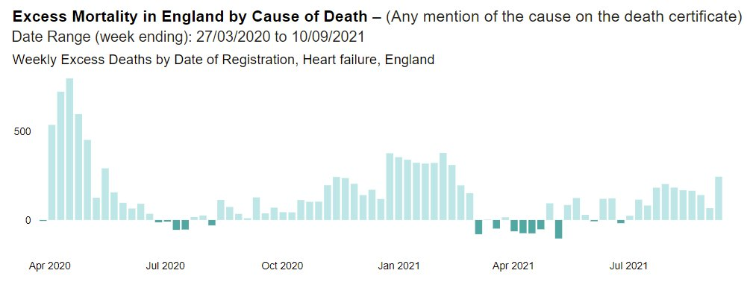
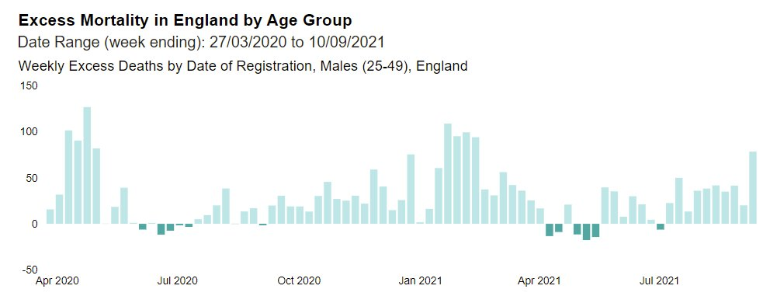

- German pathologists and doctors calling for more autopsies of dead covid vaccinated people as they are seeing vaccinated people die of very unusual and strange illnesses.
https://www.sueddeutsche.de/wissen/wissenschaft-heidelberg-chef-pathologe-pocht-auf-mehr-obduktionen-von-geimpften-dpa.urn-newsml-dpa-com-20090101-210801-99-647273
- We request the Irish police, the Gardai, to do a thorough investigation of excess mortality in Ireland in 2021 and 2022 and establish the relationship to the covid19 vaccine injuries and disabilities and deaths. Including autopsies of dead people to establish effects of spike proteins, graphene oxide and ADE and other side effects of the vaccines. And also establish excess mortality for heart diseases, cancers, etc. among the vaccinated.
Covid19 Vaccine Deaths and Disabilities globally – New and Disturbing Scientific and Medical evidence. Murder / Manslaughter via Experimental vaccines.
- Covid19 Vaccine kills 2 people for every 1 person it saves. And kills six 20 year olds for every one person saved. And statistical and scientific evidence from the USA points to 150,000 killed by the covid vaccine by September 2021.
At an FDA Meeting about approval for covid19 vaccines and boosters on September 17, 2021, Mr. Steve Kirsch stated that new scientific research findings show that the covid19 vaccines kill 2 people for every 1 person it saves. And kills six 20 year olds for every one person saved. This is based on the absolute all cause mortality risk associated with these covid19 vaccines. Absolute all cause mortality risk is used for other medicines and vaccines and should have been used for the covid19 vaccines. He presented the scientific findings from around the world at this FDA meeting and has them available for the courts. This also includes a very high risk of myocarditis and other heart conditions for children. The VAERS system and other tracking system worldwide confirm that the covid19 vaccines cause a wide variety of injuries and new illnesses many of which lead to premature death. And many of these deaths are not being correctly labeled as “covid19 vaccine caused deaths”. There is evidence of massive under-reporting of covid19 vaccine deaths in the USA due to several factors including cover ups by hospitals and the fact that it takes over half an hour to file one report and the vaers computer system is often down. A Harvard Medical School study and paper concluded in 2010 that VAERS under-reported actual reports by a factor of 100 and deaths and serious injuries by a factor of 10. He provided statistical and scientific evidence from the USA which points to 150,000 people killed by the covid19 vaccine by September 2021. This evidence is available below.
His evidence is corroborated by the Harvard Medical School paper of 2010 and the WHO’s database of vaccine injuries, illnesses and deaths. The documentation attached to this document is from the VigiAccess system run by the WHO. I attach a small proportion of the side effects and injuries of the covid19 vaccine and its over 18 pages. The full listing of side effects and injuries is over 115 pages and can be downloaded at https://www.data-analytica.org/side-effects.pdf . Many of these illnesses and injuries on the list are very serious and can cause early death or premature death. This has serious implications for many countries including Ireland.
There is a need to correctly label “covid19 vaccine caused deaths” and ““covid19 vaccine caused injuries or illnesses” - this is a massive challenge to health authorities and coroners worldwide including the HSE and the HPRA and the coroners in Ireland. As these covid19 vaccines affect Ireland, this testimony to the FDA in the USA is relevant and important to Ireland and court cases here in Ireland.
FDA Link - https://www.youtube.com/watch?v=WFph7-6t34M&t=15614s
and Evidence is at
https://www.skirsch.com/covid/Deaths.pdf and
https://www.skirsch.com/covid/VCage.pdf
He provides a video interview to a news reporter about this at https://rumble.com/vmkfbg-tfnt6-steve-kirsch-interviewed-by-jack-thompson-on-vaccine-safety.html
Harvard Medical School study 2010
Source: Electronic Support for Public Health–Vaccine Adverse Event Reporting System (ESP:VAERS) and https://digital.ahrq.gov/ahrq-funded-projects/electronic-support-public-health-vaccine-adverse-event-reporting-system/final-report
Mr. Steve Kirsch can be subpoenaed into the Irish courts.
- Estimating Vaccine-Induced Mortality
Matthew Crawford a well known statistician studied covid19 vaccine deaths in many countries and has estimated the fatality rate from covid19 vaccines as 411 people per million doses. This means 72,000 to 180,000 people have died from it in the USA by September 2021. This corroborates the research and number of 150,000 dead of Steve Kirsch above. Research papers below.
https://roundingtheearth.substack.com/p/estimating-vaccine-induced-mortality
https://roundingtheearth.substack.com/p/estimating-vaccine-induced-mortality-e07
- 30,305 people died within 21 days of having the Covid-19 vaccine in England during the first 6 months of 2021. 123,796 people died 21 days or more after having the Covid-19 vaccine
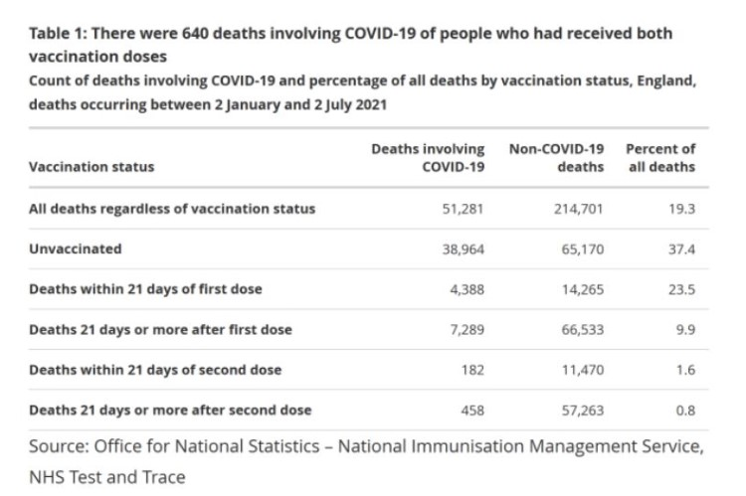
If we limit to within 21 days of a vaccination
As you can see above 14,265 people died within 21 days of having the first dose of a Covid-19 vaccine, and 4,388 people died within 21 days of having the first dose of a Covid-19 vaccine whose death allegedly involved Covid-19. This involves covid19 deaths and non covid19 deaths
Another 11,470 people died within 21 days of having their second dose of having a Covid-19 vaccine, and 182 people died within 21 days of having their second dose of a Covid-19 vaccine whose death allegedly involved Covid-19.
Therefore a total of 30,305 people died within 21 days of having the Covid-19 vaccine in England during the first 6 months of 2021. A further 123,796 people died 21 days or more after having the Covid-19 vaccine.
There is a need to correctly label “covid19 vaccine caused deaths” - this is a massive challenge to health authorities and coroners worldwide including the HSE and the HPRA and the coroners in Ireland.
- 10 times more people died of covid19 in Britain after vaccination in August 2021 than in August 2020 before the vaccination
Official government figures at https://coronavirus.data.gov.uk/details/deaths
Click on Deaths and then on Data
August 2020 (before Vaccination)
41,651 - 41,373 = 278
August 2021 (After Vaccination)
133,058 - 130,077 = 2,981
There is reason to believe that the figures for other highly covid19 vaccinated countries including Ireland are similar.
- The Chart below for Israel shows a correlation between covid19 vaccine booster doses given (cumulative booster doses per 100 people) and average daily deaths per million. There is a strong relationship. Source: https://ourworldindata.org/explorers/coronavirus-data-explorer?zoomToSelection=true&facet=none&pickerSort=asc&pickerMetric=location&Interval=7-day+rolling+average&Relative+to+Population=true&Align+outbreaks=false&country=~ISR&Metric=Confirmed+deaths
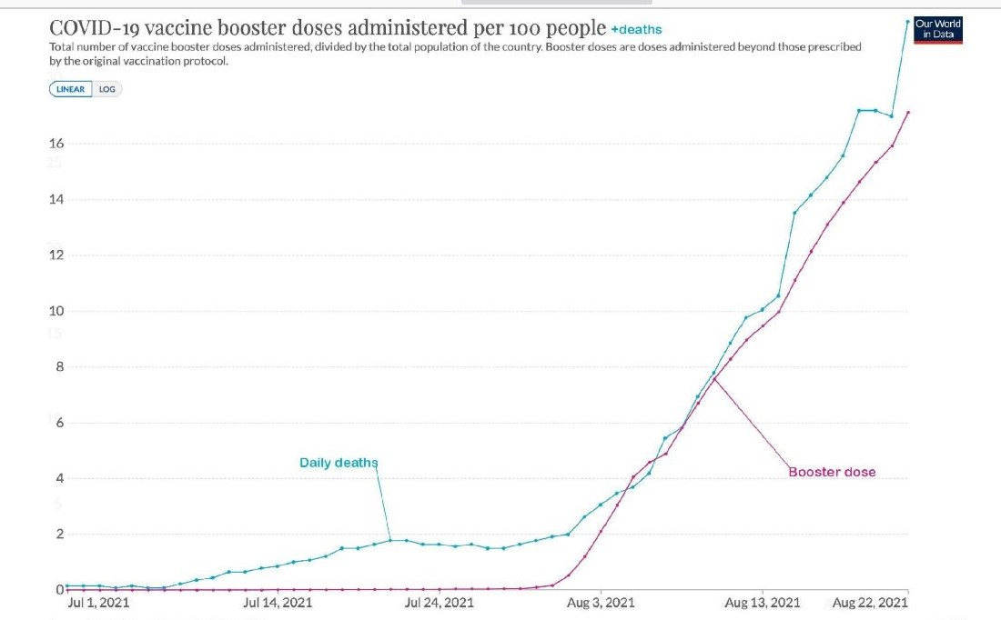

- At an FDA Meeting about covid19 vaccines and boosters on September 17, 2021, Dr Jessica Rose states that based on the VAERS Data, the risks of the covid19 vaccines and boosters far outweigh the benefits especially for children. There are 10 times more Adverse Events for vaccines in 2021 compared to the previous year and previous ten years. And 46 times more deaths for vaccines in 2021 than in previous years. These covid19 vaccines have proven to be dangerous to the general public. She also provides evidence that the covid19 vaccines are creating and driving the new variants of covid19. Video below.
https://mobile.twitter.com/NeverSleever/status/1438935548664688643?s=09
and https://www.data-analytica.org/rose.mp4

Official data shows 8 times more people have died shortly after getting the Covid-19 Vaccine in the space of 6 months than the number of people who have died of Covid-19 in 18 months
https://theexpose.uk/2021/09/22/8-times-more-deaths-covid-vaccine-than-have-died-covid/
- In Hawaii, Michael Green has filed a class action lawsuit at first representing 1,200 first responders against the Governor & Mayor's vaccine mandates with thousands more expected to join. Michael Green says that the vaccine is killing people all around the country and that at least 45,000 people have been killed by the covid19 vaccine. See news interview below:
https://rumble.com/vl316i-hawaii-attorney-michael-green-files-class-action-lawsuit-says-vaccine-has-k.html
- Doctors for Covid Ethics is an organization of hundreds of medical doctors and scientists worldwide. They have called for a halt to covid19 vaccines based on medical and scientific evidence showing high levels of deaths and illnesses and disabilities from these vaccines and significant dangers to the general public. Their web site is https://doctors4covidethics.org/
- Dr. Peter McCullough is an Internist, Cardiologist, Epidemiologist, and Professor of Medicine at Texas A & M College of Medicine, Dallas, Texas in USA. He has experience in successfully treating many covid19 patients in the USA. He has a vast medical and scientific knowledge of the covid19 virus and pandemic and is highly regarded in medical and scientific circles globally.
Dr. Peter McCullough claims we could have saved 85% of covid19 patients from death using the safe and effective medicines listed in this document and in our other books of evidence. This includes Ivermectin, hydroxychloroquine, Budenoside, the Zelenko protocol, the Fareed and Tyson protocol, etc.
Link to news interview - https://rumble.com/vhp7y5-full-interview-world-renowned-doctor-blows-lid-off-of-covid-vaccine.html
Dr. Peter McCullough will be subpaoened into the Irish courts to testify.
- mRNA COVID-19 Vaccination and Development of CMR-confirmed Myopericarditis
https://www.medrxiv.org/content/10.1101/2021.09.13.21262182v1
- Covid Vaccines adversely affecting the Immune system including the Toll Receptors and Innate Immunity. This is leading to a reactivation of Shingles and herpes viruses and to a worsening of cancers. Scientific paper below.
The BNT162b2 mRNA vaccine against SARS-CoV-2 reprograms both adaptive and innate immune responses.
Fohse et al. May 2021
https://www.medrxiv.org/content/10.1101/2021.05.03.21256520v1
and video interview with Dr. Ryan Cole at https://www.bitchute.com/video/fbWGA1CEMK2W/
- Swiss Policy Research article - ‘Covid Vaccines and Cancer’
https://swprs.org/covid-vaccines-and-cancer/
- Why are we vaccinating children against COVID-19?
Kostoff et al. . September 2021
Toxicology Reports
https://www.sciencedirect.com/science/article/pii/S221475002100161X#bib0020
‘ A novel best-case scenario cost-benefit analysis showed very conservatively that there are five times the number of deaths attributable to each inoculation vs those attributable to COVID-19 in the most vulnerable 65+ demographic’
- Absolute All Cause Mortality risk from covid19 vaccines and boosters
There is a need for the FDA in USA and the HSE in Ireland and SAGE in Britain to measure Absolute All Cause Mortality Risk of covid19 vaccines and boosters
The absolute all cause mortality risk of the covid19 vaccines and boosters need to be measured by health authorities and governments in all countries. This is especially important given all the adverse effects including deaths from these vaccines - see https://www.skirsch.com/covid/Deaths.pdf
This is a table comparing the rate of adverse events this year relative to the annual VAERS incidence rate reported for all vaccines over the period from 2015-2019 for ages 20 to 60. We limited the age range to show that these events are affecting young people and not just the elderly. Also, the signal to noise ratio is much stronger in this younger age group since they are less likely to suffer “background” adverse events.
A value of 473 means the rate reported in VAERS for the COVID19 vaccines in 2021 was 473 times higher than what is typical for all vaccines combined in the typical average year. Nearly all serious adverse events we looked at were strongly elevated compared to the expected normal baseline event rate. This table is useful when assessing whether the vaccine may have been involved in causing death in cases. The symptoms listed here are consistent with the presumed mechanism of action for how these vaccines kill people (producing spike protein throughout the body that cause inflammation, scarring, and blood clots). Surprisingly, only a few of these symptoms appear in the labelling of the recently approved Pfizer vaccine. Thus, this table is important and timely.
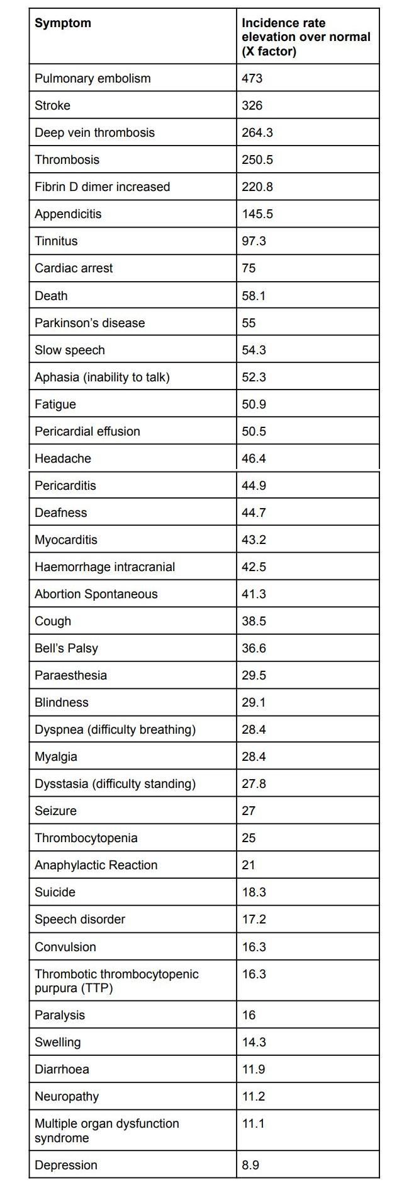
Source: https://www.skirsch.com/covid/Deaths.pdf
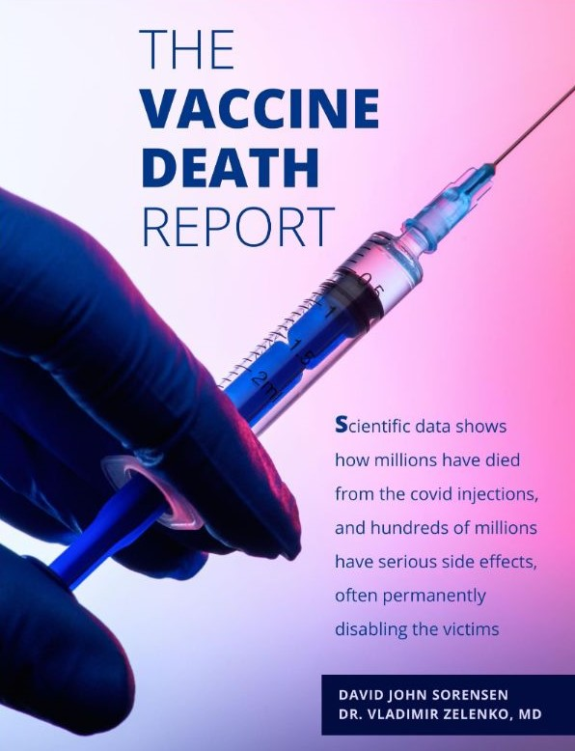

Download this report at https://www.stopworldcontrol.com/downloads/en/vaccines/vaccine-death-report.pdf
or www.data-analytica.org/vaccine-report.pdf
Evidence shows that Covid19 Vaccines are losing effectiveness and not working and are becoming ineffective. Another reason to abolish and end vaccine passports and vaccine mandates.
- New PHE Data in Britain Shows Vaccine Effectiveness Against Delta Down to Just 7.6% in the Over-50s, 24% in the Under-50s, as the Vaccinated Continue to Experience Higher Infection Rate
https://dailysceptic.org/2021/09/18/new-phe-data-shows-vaccine-effectiveness-against-delta-down-to-just-7-6-in-the-over-50s-24-in-the-under-50s-as-the-vaccinated-continue-to-experience-higher-infection-rate/
- PHE data from Britain shows continuing evidence that the covid19 vaccines are losing effectiveness and are ineffective. News reports below.
Vaccines Have NEGATIVE Effectiveness in the Over-40s, as Low as MINUS 38%, Shows New PHE Report
https://dailysceptic.org/2021/09/10/vaccines-have-negative-effectiveness-in-the-over-40s-as-low-as-minus-38-shows-new-phe-report/

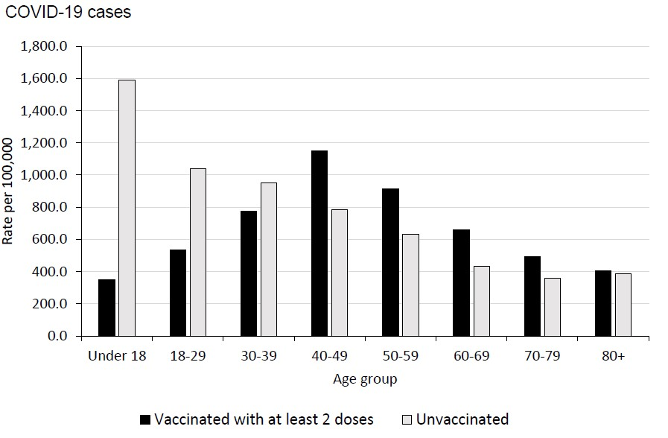

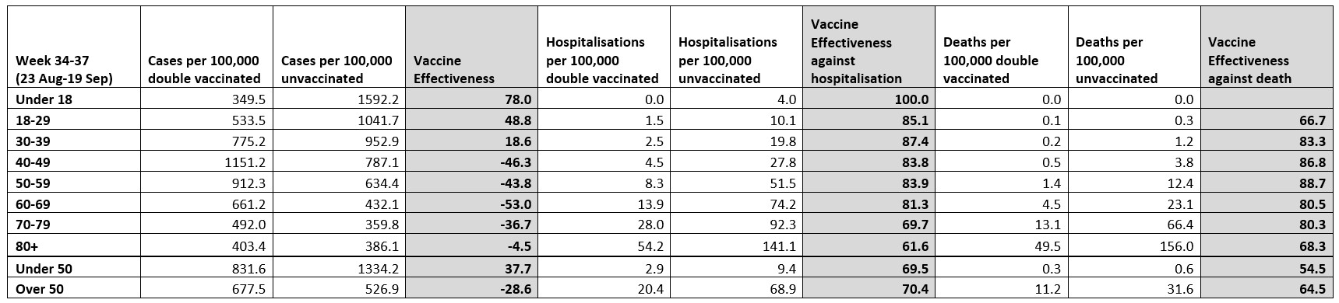

Vaccine effectiveness is negative for several age groups and is very low overall and this is declining every week and month.
And
A comparison of age adjusted all-cause mortality rates in England between vaccinated and unvaccinated - The UK Government's own data does not support the claims made for vaccine effectiveness/safety
http://probabilityandlaw.blogspot.com/2021/09/all-cause-mortality-rates-in-england.html

Official data reveals 67% of Covid-19 deaths since February 2021 have been people who were vaccinated
https://theexpose.uk/2021/08/25/official-data-reveals-67-of-covid-19-deaths-since-february-2021-have-been-people-who-were-vaccinated/
- Israel one of the most covid19 vaccinated countries in the world has endured a big rise in covid19 cases and deaths after the mass vaccinations. It’s government and health authorities admits that the covid19 vaccines are not working. Even after 2 vaccinations and a booster for most of the Israel population, the covid19 cases have increased and reached a new record high.
Health Ministry chief says coronavirus spread reaching record heights
The Times of Israel, 14 September 2021
https://www.timesofisrael.com/health-ministry-chief-says-coronavirus-spread-reaching-record-heights/
Top Israeli Health Official: Vaccinated people account for 95% of severe and 85-90% of new COVID hospitalizations
https://thebl.com/health/top-israeli-health-official-vaccinated-people-account-for-95-of-severe-and-85-90-of-new-covid-hospitalizations.html
Israel’s Covid chief calls for fourth vaccine dose
https://www.independent.co.uk/news/world/middle-east/covid-vaccine-israel-fourth-dose-b1915076.html
- Waning immunity of the BNT162b2 vaccine: A nationwide study from Israel
Goldberg et al. August 2021.
https://www.medrxiv.org/content/10.1101/2021.08.24.21262423v1
- Portugal, Sweden slap COVID entry ban on Israelis, including those vaccinated
https://www.timesofisrael.com/portugal-sweden-slap-covid-entry-ban-on-israelis-including-those-vaccinated/
- US COVID-19 Vaccines Proven to Cause More Harm than Good Based on Pivotal Clinical Trial Data Analyzed Using the Proper Scientific Endpoint, “All Cause Severe Morbidity”
by Dr. J Bart Classen, August 2021
http://www.skirsch.com/covid/Morbidity.pdf
- Covid-19 deaths are rapidly rising but less than 25% of them are unvaccinated people; it’s time to admit the jab doesn’t work, stop injecting kids, and get back to normal
https://rightsfreedoms.wordpress.com/2021/09/04/exclusive-covid-19-deaths-are-rapidly-rising-but-less-than-25-of-them-are-unvaccinated-people-its-time-to-admit-the-jab-doesnt-work-stop-injecting-kids-and-get-back-to-n/

Delta scuppers New Zealand’s hopes of eliminating virus according to Health Chief
https://www.thetimes.co.uk/article/new-zealands-strategy-to-eliminate-coronavirus-faces-defeat-by-delta-strain-admits-health-chief-qq3wh2zdw
- Two top FDA officials and scientists involved in vaccine development, approval and monitoring resigned from the FDA over the covid19 booster scandal in the USA. Too much political interference in the FDA and its covid vaccine program. News reports below:
https://arstechnica.com/science/2021/09/anger-frustration-at-fda-over-bidens-booster-plan-two-top-regulators-resign/
https://www.google.com/search?&q=two+FDA+resign
and
paper published by these resigned FDA scientists in the Lancet medical journal
https://www.thelancet.com/journals/lancet/article/PIIS0140-6736(21)02046-8/fulltext
- FDA panel votes 16-2 AGAINST recommending to approve Pfizer booster shots to healthy people under 65 because there is not enough evidence they are safe and effective
https://www.dailymail.co.uk/health/article-10002725/FDA-advisory-committee-votes-NOT-recommend-approval-booster-shots.html
- Statistical Analysis of the failure of Covid19 Vaccines
This is a very important statistical paper by Dr. Carmen Elena Dorobăț
https://mises.org/wire/public-health-officials-say-trust-us-data-says-otherwise

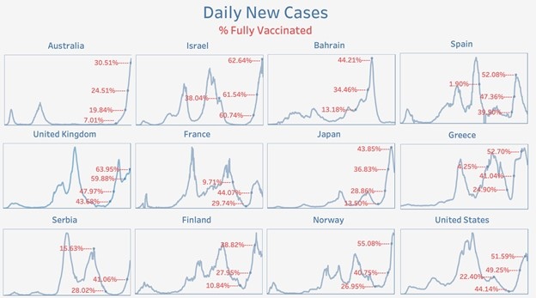
Source: Data on cases and vaccination from Our World in Data COVID-19 dataset (new_cases, people_fully_vaccinated)

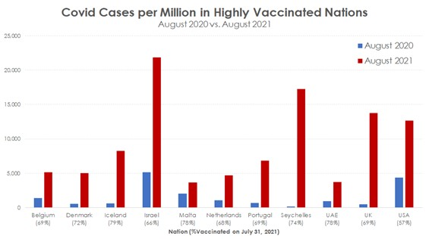
Source: Data on cases and vaccination from Our World in Data COVID-19 dataset (total_cases_per_million, people_vaccinated).
- More scientific papers showing the vaccines are not effective
The SARS-CoV-2 Delta variant is poised to acquire complete resistance to wild-type spike vaccines.
Liu et al. August 2021
https://www.biorxiv.org/content/10.1101/2021.08.22.457114v1.full.pdf
- COVID vaccine immunity is waning — how much does that matter
Nature Magazine. September 17 2021
https://www.nature.com/articles/d41586-021-02532-4
- A scientific analysis of - ‘Why so many Americans are refusing to get vaccinated’
This contains important scientific and medical findings from the USA and around the world
http://www.skirsch.com/covid/Refuse.pdf
Resignations of top FDA Officials over the issue of covid19 Boosters
Two senior FDA officials involved in vaccine monitoring and approvals resigned in September 2021 over political interference in the covid19 booster shots and the intense pressure to approve them despite concerns over the safety and efficacy of the boosters and the overall mortality risk. Politicians under pressure from Big Pharma lobbyists and conflicts of interest are playing a role in pushing the vaccine and boosters agenda. This is very significant and shows that honest scientists who stand up for Science and scientific truths are being intimidated, threatened and forced out of jobs and careers. This has massive implications for Science and the Law and rule of law in the USA and in many other countries such as Ireland and the European Union which follow the FDA’s advice and policies.
I attach paper published by these resigned FDA scientists in the Lancet medical journal
https://www.thelancet.com/journals/lancet/article/PIIS0140-6736(21)02046-8/fulltext
And I attach an important news report about this titled ‘The Meaning of the FDA Resignations’ by Jeffrey Tucker. Also available at https://brownstone.org/articles/the-meaning-of-the-fda-resignations/
Scientists Finds Poisons and Toxins in the Covid19 Vaccines and also find Blood abnormalities in the blood of covid19 vaccinated people
- Dr. Robert Young a renowned scientist joined Stew Peters for an EXCLUSIVE, very candid conversation about his past, along with his findings after he examined the Pfizer, Moderna, J&J and Astrazeneca vials containing the "secret" contents of the COVID shots being called "vaccines". Link below.
https://rumble.com/vm7iyp-dr.-robert-young-whats-in-covid-shots-why-graphene-who-is-responsible.html
- Blood clots and strings and strange objects in the blood of covid vaccinated people. Video of scientist showing slides of blood under a microscope. This is compared to the blood of unvaccinated people.
https://www.brighteon.com/40413094-fbe6-44c8-b5d8-9cab4cfe8e1a
and
https://www.bitchute.com/video/JnAbhldv33VG/

Reckless Endangerment of Children in Ireland and other countries -
Should children be seriously injured or disabled or killed by these experimental vaccines when they have no significant risk from covid19 ?

In addition to the many illnesses and disabilities afflicting adults, children also have a higher risk of heart illnesses from these covid19 vaccines in addition to higher risks for other illnesses some of them fatla and of them disabling.. These illnesses and disabilities are detailed on
www.data-analytica.org/page2.htm and on www.data-analytica.org/side-effects.pdf

360,000 teens age 12 to 17 develop heart conditions after Covid-19 shots. with many cases need hospitalization
https://www.newsbreak.com/news/2337411633472/360-000-teens-age-12-to-17-develop-heart-conditions-after-covid-19-shots-with-many-cases-need-hospitalization
and https://www.upi.com/Health_News/2021/08/10/coronavirus-vaccine-teens-myocarditis-study/9051628602366/

SARS-CoV-2 mRNA Vaccination-Associated Myocarditis in Children Ages 12-17: A Stratified National Database Analysis
https://www.medrxiv.org/content/10.1101/2021.08.30.21262866v1
The medium and long term effects of these poisons and toxins in the vaccines are not known but the short term effects detailed on some web sites such as www.data-analytica.org/page2.htm are extremely worrying for parents and their children.

Boys more at risk from Pfizer jab side-effect than Covid, suggests study
The Guardian, September 2021
https://www.theguardian.com/world/2021/sep/10/boys-more-at-risk-from-pfizer-jab-side-effect-than-covid-suggests-study
and in TELEGRAPH NEWSPAPER at
https://www.telegraph.co.uk/news/2021/09/09/teenage-boys-risk-vaccines-covid/

Professor Finn, a member of the Joint Committee on Vaccination and Immunisation in Britain and a senior government advisor, says that in normal times, the vaccine would not have been recommended for widespread use in children until the long-term consequences of rare side effects had been fully investigated. Parents are justified in waiting until the risks are clearer before getting their teenagers vaccinated and the NHS needs to spell out the uncertainty over long-term effects better, he argues ……………………………………………………….
News story here at https://www.thetimes.co.uk/article/children-should-know-about-tiny-risk-from-covid-vaccine-insist-experts-5c5nwffxt

Why are we vaccinating children against COVID-19?
Kostoff et al. . September 2021
Toxicology Reports
https://www.sciencedirect.com/science/article/pii/S221475002100161X#bib0020
‘ A novel best-case scenario cost-benefit analysis showed very conservatively that there are five times the number of deaths attributable to each inoculation vs those attributable to COVID-19 in the most vulnerable 65+ demographic’

Young adult mortality in Israel during the COVID-19 crisis
by Dr Steve Ohana and Dr Alexandra Henrion-Caude
https://steve-ohana.medium.com/young-adult-mortality-in-israel-during-the-covid-19-crisis-ff7456cff74f
- At an FDA Meeting about covid19 vaccines and boosters on September 17, 2021, Dr Jessica Rose states that based on the VAERS Data, the risks of the covid19 vaccines and boosters far outweigh the benefits especially for children. There are 10 times more Adverse Events for vaccines in 2021 compared to the previous year and previous ten years. And 46 times more deaths for vaccines in 2021 than in previous years. These covid19 vaccines have proven to be dangerous to the general public. She also provides evidence that the covid19 vaccines are creating and driving the new variants of covid19. Video below.
https://mobile.twitter.com/NeverSleever/status/1438935548664688643?s=09
and https://www.data-analytica.org/rose.mp4

Myocarditis in Children
COVID-19 Vaccine Safety in Adolescents Aged 12–17 Years — United States, December 14, 2020–July 16, 2021
https://www.cdc.gov/mmwr/volumes/70/wr/mm7031e1.htm

Biological and molecular evidence why children are effectively COVID immune and can be considered already vaccinated
Paul Alexander, Trial Site News.
https://trialsitenews.com/covid-injections-offer-children-no-opportunity-for-the-benefit-and-only-potential/

Unvaccinated children getting infected with Covid isn't an issue because they face such a vanishingly rare chance of falling seriously ill, expert says
The Daily mail, 23 September, 2021
https://www.dailymail.co.uk/news/article-10021243/Scientists-slam-Chris-Whitty-scare-mongering-unjabbed-children-Covid.html
The Lack of or Absence of Informed Consent when giving the covid19 vaccines and boosters

Under US law and Irish law and EU law, informed consent must be given which means a person must be told about the side effects, injuries, disabilities and deaths caused by the vaccine. This has not been done in the USA and Ireland in the European Union. Giving experimental vaccines to people without their informed consent is a crime and there are several laws which deal with this.
The FDA knew about the many serious injuries and disabilities and deaths caused by the covid19 vaccines more than 53 days before the first vaccine shot on 14 December 2020 was given. The FDA held a conference online about this on 22 October 2020 ; see evidence of this below. They still provided emergency approval for these vaccines when they knew about these dangers. Also they did not fully inform the American public and the public in other countries including the public in Ireland and Britain about the injuries and disabilities and deaths caused by the covid19 vaccines. The EMA also refused to inform the populations of the European Union including Ireland about these FDA findings in the USA. These FDA findings did not appear in the list of side effects accompanying these vaccine products and were not communicated to people receiving the vaccines. Informed consent was not given in the USA and in the European Union including Ireland. This is a serious breach of the law and of the Nuremberg Code and the Geneva Convention and is a crime.
Screenshot of FDA conference below

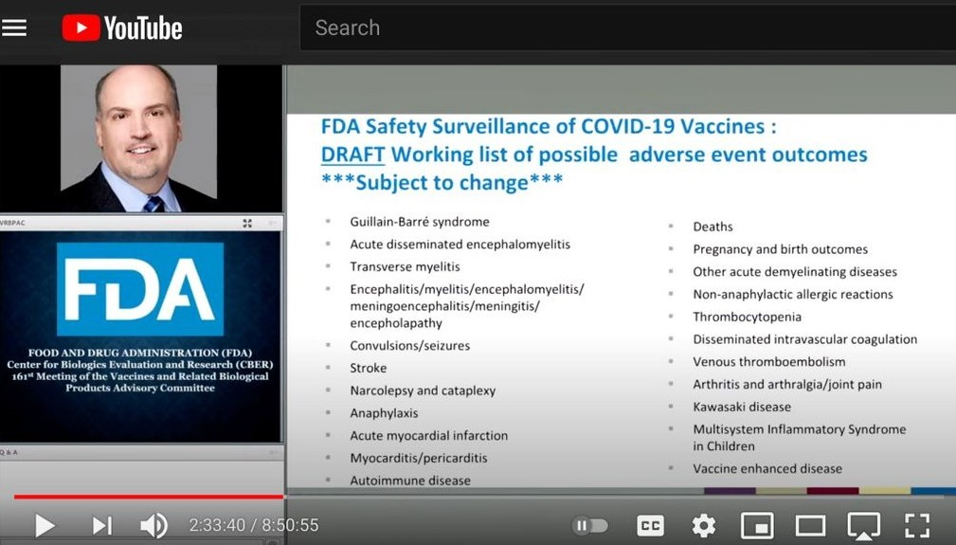

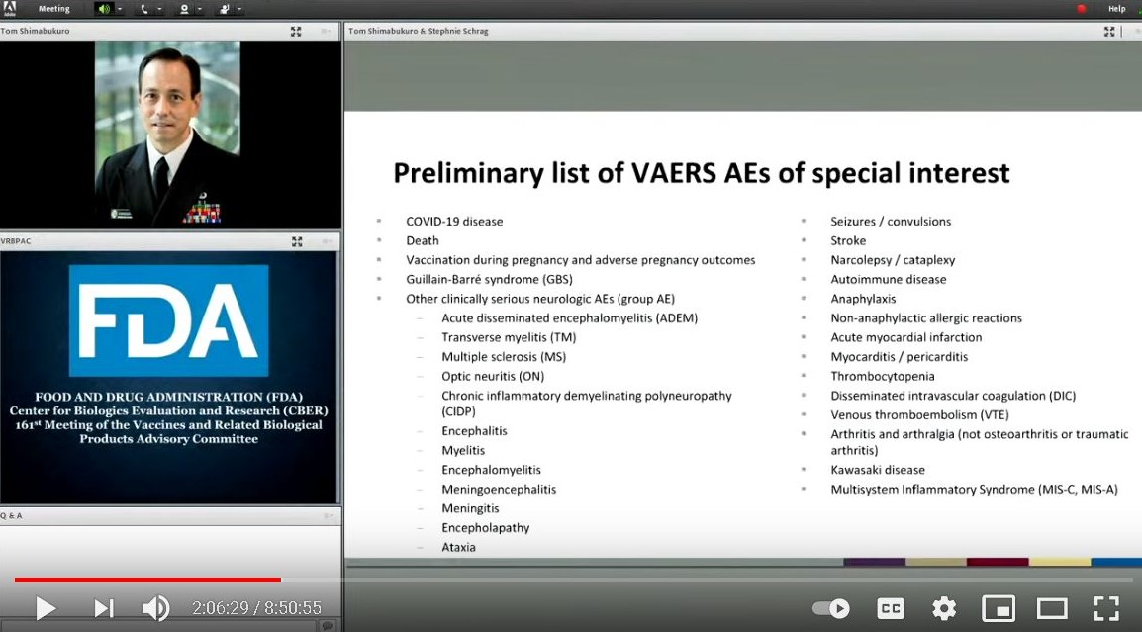

Link to evidence and conference on FDA web site https://www.fda.gov/media/143557/download
and www.data-analytica.org/FDA2.pdf

The WHO has such a listing of side effects, injuries, disabilities and deaths, 115 pages long viewable at www.data-analytica.org/side-effects.pdf .
Covid19 vaccines do not meet the following five requirements to be scientifically and legally considered a vaccine
The “vaccine” fails to meet the following five requirements to be considered a vaccine and is by definition a medical “experiment” and trial:
Provides immunity to the virus
This is a “leaky” gene therapy that does not provide immunity to Covid and claims to reduce symptoms yet double-vaccinated are now 60% of the patients requiring ER or ICU with covid infections.
Protects recipients from getting the virus
This gene-therapy does not provide immunity and double-vaccinated can still catch and spread the virus.
Reduces deaths from the virus infection
This gene-therapy does not reduce deaths from the infection. Double-Vaccinated infected with Covid have also died.
Reduces circulation of the virus
This gene-therapy still permits the spread of the virus as it offers zero immunity to the virus.
Reduces transmission of the virus
This gene-therapy still permits the transmission of the virus as it offers zero immunity to the virus.
Covid19 Vaccine Passports and Mandates
- U.S. judge blocks N.Y. vaccine mandate for healthcare workers
Reuters, September 2021
https://www.reuters.com/world/us/us-judge-blocks-ny-vaccine-mandate-healthcare-workers-2021-09-14/

Covid19 Vaccine Passports and mandates leading to shortages in doctors and nurses and hospital staff in hospitals and clinics in several countries
- Nurse shortages in California reaching crisis point
https://calmatters.org/health/coronavirus/2021/08/california-nurses-shortage/
- Some hospitals are foregoing vaccine mandates to avert staffing shortages
https://fortune.com/2021/08/30/health-care-hospital-worker-shortage-vaccine-mandates-staff-retention/
- AHA concerned federal vaccine mandate could exacerbate severe worker shortage
https://www.fiercehealthcare.com/hospitals/aha-concerned-federal-vaccine-mandate-could-make-workforce-shortages-worse
- NY hospital to pause baby deliveries after resignations over Covid-19 vaccine mandate
https://edition.cnn.com/2021/09/12/health/ny-hospital-pausing-baby-deliveries-covid-19-resignations/index.html
- Nebraska is recruiting unvaccinated nurses to plug a staffing shortage
https://www.nytimes.com/2021/08/26/us/nebraska-delta-nurses-unvaccinated.html

Court cases about Unlawful and Illegal Lockdowns and Prosecutions in courts which have implications for Ireland

Every prosecution under emergency Covid powers was wrong, review finds
The Telegraph, September 17, 2021
https://www.telegraph.co.uk/news/2021/09/17/every-prosecution-emergency-covid-powers-wrong-official-review/
Saving Lives from covid19 and it’s variants and Saving Lives from Dangerous Covid19 Vaccines
- Scientists and medical doctors are collaborating to put forward effective and safe medications for covid19 and it’s variants which does not involve experimental and dangerous vaccines. See Covid19 Early Treatment Fund at https://www.treatearly.org/
This can be deployed in Ireland and other countries to save lives. This is proposed to the HSE and Irish hospitals and the Irish government. Failure to do so would place lives at risk.
- Fareed and Tyson Protocol
This protocol by medical doctors in the USA has proven to be very successful against covid19 and it’s variants. Ivermectin and Hydroxychloroquine are part of it.
Dr. George Fareed and Dr. Brian Tyson share early treatment protocol, see link below.
https://www.thedesertreview.com/news/dr-george-fareed-and-dr-brian-tyson-share-early-treatment-protocol/article_7728815e-3ca2-11eb-8a08-7b4b0156c181.html
- News report from India - HUGE: Uttar Pradesh, India Announces State Is COVID-19 Free Proving the Effectiveness of “Deworming Drug” IVERMECTIN
https://www.thegatewaypundit.com/2021/09/huge-uttar-pradesh-india-announces-state-covid-19-free-proving-effectiveness-deworming-drug-ivermectin/
- Dr. Peter McCullough claims we could have saved 85% of covid19 patients from death using the safe and effective medicines listed in this document and in our other books of evidence. This includes Ivermectin, hydroxychloroquine, the Zelenko protocol, the Fareed and Tyson protocol, etc.
Link to news interview - https://rumble.com/vhp7y5-full-interview-world-renowned-doctor-blows-lid-off-of-covid-vaccine.html
Dr. Peter McCullough will be subpaoened into the Irish courts to testify.

More Scientific Evidence proves that Natural Immunity including Recoveries from covid19 are far better protected than the covid19 vaccinated. This also supports the use of safe and effective medicines in the previous section which both kill covid19 and its variants while allowing the immune system to develop natural and long lasting immunity to this virus.

- Significant reduction in humoral immunity among healthcare workers and nursing home residents 6 months after COVID-19 BNT162b2 mRNA vaccination
https://www.medrxiv.org/content/10.1101/2021.08.15.21262067v3
- Comparing SARS-CoV-2 natural immunity to vaccine-induced immunity: reinfections versus breakthrough infections
https://www.medrxiv.org/content/10.1101/2021.08.24.21262415v1
- COVID-19 Natural Immunity Debate Continues
https://www.precisionvaccinations.com/covid-19-natural-immunity-debate-continues
Expert Testimony regarding Covid19 and Covid19 Vaccines and Passports to the Michigan State Parliament in the USA
Cellular and molecular biologist Dr. Christine Parks recently gave testimony on Michigan House Bill 4471. Her testimony went viral. Without hesitation, Dr. Parks believes that what is taking place is more of a narrative than a science. In fact, she believes there is a coverup going on concerning the “virus” and the vaccine shots being given and believes it is dangerous. Listen to this interview to find out why PhD’s are among the “most vaccine hesitant.”
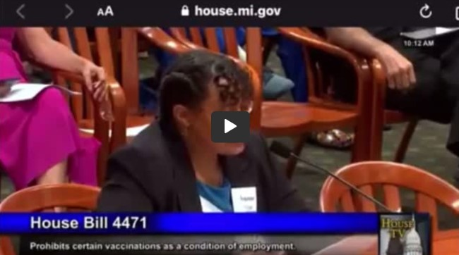
Link https://rumble.com/vloa7j-must-watch-expert-testimony-on-mandatory-vaccination-and-medical-coercion.html
Dr. Christina Parks received her Ph.D. in Cellular and Molecular Biology from the University of Michigan in 1999. She did her graduate research in the field of cytokine signaling. Cytokines are the chemicals that the immune system uses to communicate. Thus Dr. Parks brings a wealth of knowledge about the molecular mechanisms by which vaccines may be causing injury to vulnerable immune systems. She has garnered significant attention for her testimony on Michigan House Bill 4471 which seeks to ban discrimination based on vaccine status. In her testimony, she challenged the assumption that COVID vaccines prevent transmission and called vaccine mandate supporters on the carpet for essentially supporting a return to racial segregation since 70% of the African American population are refusing Covid vaccines and will now be excluded from education and the workforce.
Unlawful and Illegal use of Remdesivir for covid19
Remdisivir is being used to treat covid19 despite many scientific studies showing it is unsafe and ineffective. It has serious side effects on the kidneys and lungs and heart and is causing a high percentage of deaths. The FDA and EMA did not measure the absolute all cause mortality risk of Remdisivir before approving it and after approving it for coivd19. Many deaths caused by Remdesivir in 2020 and 2021 were mislabelled as “covid19 deaths” due to the high rate of False Positives in PCR tests.
I include links to science and scientific papers below:
https://www.google.com/search?q=remdesivir+fatality
https://duckduckgo.com/?q=remdesivir+fatality&t=hx&va=g&ia=web
https://www.bitchute.com/video/3sGAoYTZA2bb/
More Information on unnecessary and unjustified Lockdowns killing millions of persons with non covid19 illnesses such as cancers, heart diseases, etc.
The Lockdowns led to the cancellation of over 100,000 hospital appointments in Ireland in 2020 and 2021 and to millions of cancelled appointments in Europe and North America and around the world. This has serious implications for those people with cancers and heart diseases etc. etc. which are life threatening illnesses and who now face premature deaths due to the lockdowns. This amounts to murders / manslaughters caused by lockdowns. A recent news article about this in the Telegraph at https://www.telegraph.co.uk/columnists/2021/09/21/cancer-backlog-scandal-much-worse-think/
and
https://dailysceptic.org/2021/09/21/extra-10000-brits-likely-to-die-of-cancer-due-to-drop-in-emergency-referrals-during-lockdown-according-to-new-study/
and
Thousands more people than usual are dying ... but it’s not from Covid
https://www.telegraph.co.uk/news/2021/09/24/analysis-thousands-usual-dying-not-covid/

False Covid19 Statistics in Hospitals
In Britain the NHS has been exposed for counting those with people admitted for other illnesses and diseases and accidents and covid19 vaccine injuries and illnesses as “covid19”. The positive test for covid19 including the high rate of false positives meant people with other illnesses and diseases including covid19 vaccine injuries and illnesses and treated for these in hospital were mislabelled as “covid19”, and this has been occurring for most of 2021. These false statistics have worked to increase the panic and fear in Britain and support further lockdowns and vaccine passports.
News story at https://dailysceptic.org/2021/09/18/a-doctor-writes-the-nhs-is-concealing-important-information-from-the-public/
The Failure of Lockdowns
- Covid19 Lockdowns and Sweden
Sweden had 0.03% excess mortality in 2020 despite no lockdowns. This showed the futility and ineffectiveness of lockdowns. We already had effective and safe medicines for covid19 since March 2020 but they were unlawfully banned or blocked in some countries including Ireland and most covid19 cases were told to go home and isolate and not take any medicines by misinformed Irish doctors. Some Irish doctors and scientists and legal experts discussed this recently in a public debate, see link below
https://theplatform.ie/sweden-no-lock-downs-no-masks-03-excess-deaths-we-got-a-torrent-of-fear-driven-nonsense-from-rte-nphet-gov/
Swedish State Epidemiologist Anders Tegnell tells UnHerd: “I think we tried to argue from fairly early on that this is a disease we have to learn to live with… And more and more countries are taking that position.” News report below.
https://unherd.com/thepost/anders-tegnell-sweden-won-the-argument-on-covid/
- Norway
Norway ends all covid19 restrictions on September 25 2021 and now views covid19 as a seasonal flu. This corroborates all of our evidence presented to the police and DPP.
https://www.theepochtimes.com/mkt_morningbrief/norway-official-covid-19-can-now-be-compared-to-the-flu-as-country-removes-pandemic-restrictions_4014597.html
- Statistical Analysis of the Failure of Lockdowns
This is a very important statistical paper by Dr. Carmen Elena Dorobăț
https://mises.org/wire/public-health-officials-say-trust-us-data-says-otherwise
- Lecture by Dr. Clare Craig a top Pathologist in the UK
Dr. Clare provides scientific evidence and a clear explanation of why the lockdowns failed. She explains that covid19 and many other respiratory viruses including flu’s and colds are spread through the air and are widely distributed all over the earth. We are surrounded by viruses and bacteria and the key factor is one’s susceptibility to infection – the status and strength of one’s immune system. She also explains that there is no evidence for asymptomatic transmission of covid19. The key factor is the strength of one’s immune system and the season of the year including sunshine and Vitamin D levels, and factors which affect one’s immune system such as Vitamin D and Vitamin C and zinc and nutrition and stress levels and the government’s investment in ICU’s and hospital staff and infrastructure. Lecture viewable at
https://www.youtube.com/watch?v=veSfwMZhZRA&t=1s
- Variant infections are occurring in countries and states which are locked down and not locked down in 2021. The variants spread regardless of the lockdowns. In India the surge in variants was only brought under control once the widespread use of Ivermectin was restored. Some research into the experience of Uttar Pradesh in India will be necessary for many Irish medical doctors and scientists and NPHET. I include news report below:
https://dailysceptic.org/2021/09/21/the-role-of-variants-in-driving-surges-is-good-news-for-sceptics/

Ivermectin being used by the Government and health authorities of El Salvador to treat covid19 patients and to prevent infections
There are several news reports about this. The treatment protocol and prevention protocol are proving effective, very safe and successful in El Salvador.
https://trialsitenews.com/el-salvador-minister-of-public-health-includes-ivermectin-as-covid-19-pandemic-continues/
https://www.google.com/search?&q=el+salvador+ivermectin
Hospital Whistleblowers
- Project Veritas interviewed a hospital nurse who works for the HHS in USA about the covid19 vaccines and she discussed the injuries and disabilities and deaths caused by the covid19 vaccines and the cover ups. She also mentions the illegal and unlawful banning and blocking of Ivermectin in American hospitals. And the blackmail and threats against hospital nurses and doctors.
https://www.youtube.com/watch?v=obdI7tgKLtA . This is also happening in Ireland and several other countries.

Australia being used as an example for Totalitarian government and brutal suppression of Constitutional rights, Civil Rights and Human Rights and the subversion of Democracy and the introduction of concentration camps
News from Australia in August and September 2021 showed the police and the military being used to enforce brutal lockdowns and to use violence against peaceful protestors. Many protestors have been seriously injured and hospitalised. The aim of some state government officials is to achieve zero covid19 and variants or a high rate of vaccinations and to use lockdowns and brutal suppression of democratic rights and human rights to achieve this. By mid September 2021 Australia had been turned into a fascist state with dictators using the police and military to lock down and brutally attack innocent civilians. So called ‘quarantine camps’ which function as concentration camps have been built to hold innocent people. While effective medical drugs for covid10 such as Ivermectin and Hydroxychloroquine have been banned by the Australian government and medical authorities. This vicious attack on Democracy has shocked many nations around the world.
This brutal policy in Australia follows the Strategic Intelligence Agenda of the World Economic Forum and the Lockstep program of the Rockefeller Foundation. This is publicly available to read. This is their “great re-reset” which they plan to bring into many nations around the world including Ireland.

The Corona Investigative Committee has gathered evidence for the German Courts and International Criminal Court and this evidence has Relevance to Ireland and can be used in Ireland
The Corona Investigative Committee set up by Reiner Fuellmich a German lawyer and American lawyer has gathered and presented evidence for the courts in Germany and the International Criminal Court. Reiner Fuellmich is working with other lawyers and over one hundred scientists and medical doctors and professors to bring court cases against the lockdowns, PCR test frauds, deaths in nursing homes, and vaccines and vaccine passports in Germany and in the international criminal court. In fact, evidence to be presented in the German courts is international in scope and can be presented in the Irish courts. The same covid19 frauds perpetrated in Germany are also occurring in Ireland and other countries.
See https://corona-ausschuss.de/en/
The evidence gathered by the Corona Investigative Committee corroborates our evidence given to the Irish police and being prepared for the Irish courts.
Injuring and Disabling Millions of People and Killing hundreds of thousands of people :
Covid19 Vaccines have the longest list of side effects and injuries of all vaccines in history according to the WHO and it’s VigiAccess system and to VAERS in USA and the EMA database for vaccine injuries in the EU. Massive pressure on Hospitals and Medical Clinics.
The following documentation is from the VigiAccess system run by the WHO. I attach a small proportion of the side effects and injuries of the covid19 vaccine and its over 18 pages. The full listing of side effects and injuries is over 115 pages and can be downloaded at https://www.data-analytica.org/side-effects.pdf
Many of these illnesses and injuries on the list are fatal and can cause early death or premature death. As this afflicts millions of people worldwide and will afflict more, this is very serious.
These side effects and injuries of the covid vaccines have led to over crowded hospitals and medical clinics in Spring and Summer 2021. They are usually quiet and empty during the Summer but not in 2021. The over crowded hospitals and medical clinics are continuing into Autumn and Winter 2021 as more people become afflicted by these side effects and injuries in addition to the new variants of covid19 among the vaccinated and unvaccinated and the many other illnesses and diseases and accidents. Many of the diagnostics and treatments for other illnesses were postphoned for over a year due to (unnecessary and unjustified) lockdowns and now they are placing additional pressure on hospitals .
There is a need for health authorities worldwide to acknowledge and properly label and classify covid19 vaccine injuries and disabilities and deaths and deal with it through appropriate medical treatments. And include this in the official government statistics and break the stats down by age group and type of covid19 vaccine injuries and disabilities and deaths.
This is very serious as it affects Ireland and many other countries. According to a Harvard medical study in 2009 - 10 the vaccine side effects and injuries and deaths are ten times higher due to under-reporting and difficulties filing reports. Its most likely that the real number of covid19 vaccine injuries and disabilities is in the millions worldwide and deaths in the hundreds of thousands by September 2021.

National Security
Fears that a New Pandemic may be Planned
Certain Big Pharma interests have been touting the threat posed by Marburg virus in the press and media and on the Internet in recent months in 2021. A PCR test was developed in 2018 for the Marburg virus and a new vaccine is being developed for it in 2021. Patents have been filed. In 2021, papers are being published about asymptomatic transmission of the Marburg virus. This means healthy people can allegedly spread this virus. This is the same type of fear used to initiate and fuel the covid19 pandemic. Fear and concerns over the threat posed by Marburg virus are being strategically and widely disseminated to create public anxiety and paranoia. There is an opportunity here to make vast profits from the spreading of the Marburg virus whether by laboratory leak or through bats or birds or other creatures or by some other method and then provide recently created PCR tests and new experimental vaccines to “solve” this problem. The same operation would be used for the Marburg virus as for covid19 involving the press and media and constant scare stories in the media accompanied by lockdowns. Major investors have invested in this vaccine company and these same investors have shareholdings in the press and media, Big Pharma, real estate, and several industries and are major contributors to political parties and politicians in North America and Europe. Massive profits and wealth creation are at stake here. Marburg virus is a deadly virus and is far worse than covid19. This profitable venture would pose serious national security risks for Ireland and Britain and the USA and many countries.
Here are some verifiable facts and evidence about this new threat:
- Bill Gates GAVI published an article on 22-Apr-2021 titled “The next pandemic: Marburg?”. There have been numerous Mainstream Media articles highlighting an upcoming threat Marburg and referencing the WHO in recent months.
- Marburg Virus is a relatively rare haemorrhagic fever which was first described in 1967, there have only been a total of 376 related deaths, and only 16 deaths since 2005.
- Primerdesign developed a one-step Real-Time PCR test genesig® in 2018 for Marburg haemorrhagic fever. Why would they develop a test in 2018 for an illness which has not had a major outbreak since 2005?
- Soligenix, are currently rushing to trial a ricin-rich vaccine RiVax® for Marburg haemorrhagic fever. RiVax has Fast Track designation for the prevention of ricin intoxication by the US FDA. Approval of ricin toxin vaccine will utilize the FDA Animal Rule to eliminate the phase 1, 2 & 3 trials. Why such a rush now, to trial a vaccine for which there has only been a total of 376 deaths since 1967 and only 16 deaths since 2005? The main component of the Rivax vaccine is Ricin is a lectin and a highly potent toxin produced in the seeds of the castor oil plant.
- Soligenix shareholders include BlacRrock Fund Advisors, Goldman Sachs & Co. LLC, etc.
- Ricin is a lectin and a highly potent toxin produced in the seeds of the castor oil plant. Ricin is very toxic if inhaled, injected, or ingested. It acts as a toxin by inhibiting protein synthesis. It prevents cells from assembling various amino acids into proteins according to the messages it receives from messenger RNA in a process conducted by the cell’s ribosome (the protein-making machinery) – that is, the most basic level of cell metabolism, essential to all living cells and thus to life itself.
- A paper tilled Asymptomatic Infection of Marburg Virus was published by the NIH in January 2021.
There is no time scale for the start of this possible pandemic but the signals and signs are there. Investors and PCR and vaccine products and patents are already in place and scare stories are emerging about the Marburg virus.
Mr. Kieran Morrissey an Engineer and statistician is one of many people who has come out publicly to express his concerns about this threat of a new pandemic. See video below.
http://flickermedia.ie/downloads/Marburg_1st_%20Cut.mp4
and he wrote an article for a news site about this.
https://www.lewrockwell.com/2021/09/no_author/a-possible-marburg-rivax-final-solution/
The evidence and facts point to new profitable opportunities from a new pandemic, a Marburg virus pandemic. Marburg virus is a deadly virus and is far worse than covid19. This is a national security issue. This issue is worthy of investigation by police and military authorities in Ireland and other countries.

Attachments
I attach two Questionnaires for national politicians and press and media executives and workers to answer. This is in the Public Interest and for the Common Good.
Questionnaires also viewable online at www.data-analytica.org/politics.pdf and www.data-analytica.org/press-media.pdf

